SCAVENGER HUNT

DUNSEITH GARDENS

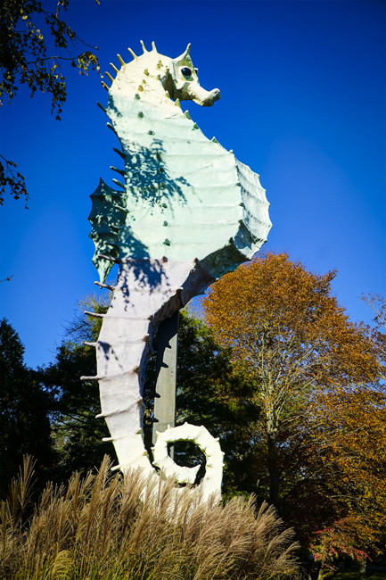
Location: Corner of 38 North Street and Route 6. Enter Driveway and parking area off of Route 6.
Please be aware of ticks when visiting properties and check yourself after visit.

Walking the property of Dunseith Gardens allows one to experience the beauty that former owner, Henry B. Dunseith desired to be preserved. He donated this property to the Mattapoisett Land Trust in 1988. The park like setting has a variety of mature trees such as Cedar, Maple, Oak, White Pine, Holly, Weeping Beech, and Magnolia.
Listen to the sounds of the running stream or calling birds. Enjoy a rest on one of the many benches or stroll the story walk to enjoy reading a children’s book.

Here are a few things to look for while you are at DUNSEITH GARDENS- check off as many as you can find! Take a picture of those items that you find interesting.
SEE…

___Pinecone from a White Pine tree

___A Cedar tree with a birdhouse attached to its trunk

___Two large white Quartz rocks stacked on each other within the stone wall that opens to the stream

___Green moss along the bank of the stream

___Find the Magnolia tree near Salty the Seahorse

___ Find the Weeping Beech tree near Salty the Seahorse

___ Which is taller, Salty the Seahorse, the Magnolia tree or Weeping Birch?

HEAR…

___The sound of the John Nichols bell

___The water flowing in the stream

___ The call of a bird

___The wind in the trees

DO…

___Sit on the colorful Bean sculpture and see if you can find a critter or two on the Bean or in the park!

___Find where the Dunseith house once stood (hint: walk up the two granite steps that lead to the front door)

___Go into the Gazebo

___ Ring the bell at The Bell Buoy

___Sit on the Denham bench and take a selfie with your family

___Relax on the “Crashing Wave” sculpture and admire the nature around you

___Visit the StoryWalk. What is the title of the book you read there?

