SCAVENGER HUNT

DEXTER AND “TUB MILL” PROPERTY

Location: Head west on Route 6 toward Fairhaven. The Park will be on your right. Take immediate right onto Mendell road. Parking lot is across from Mattapoisett Highway Department Barn.

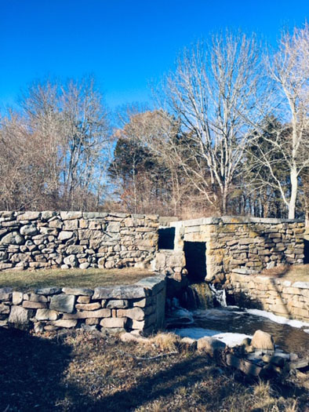
A visit to the Dexter/Tub Mill property is not only a chance to experience the beauty of this natural park like setting, but also a step back in time. Listening to the waterfall and flowing waters of Tub Mill Brook allows one to imagine the presence of a water-powered sawmill operated by the original property owner, Elisha Dexter. In the 19th and 20th century, the mill produced wooden staves for tubs and barrels. During a thunderstorm in 1911, the mill building burned down. Today only the earthen dam and millrace still exist. The historical stonework of the millrace offers a look back to the early days of the industrial revolution when rushing water from rivers and streams provided power to small village factories, such as the one that was found at this site. Mattapoisett Land Trust acquired this property in 1999.

Please be aware of ticks when visiting properties and check yourself after visit
Be cautious when standing near the stream and dam.

Here are a few things to look for while you are at DEXTER/TUB MILL PARK ~ check off as many as you can find! Take a picture of those items that you find interesting.

SEE…
___A fallen tree

___Some green leaves

___The big tree split in half by a wind storm

___A stonewall

___A Gall on the branch of a Cedar Tree

___2 Cedar trees growing from one trunk

___A large bird’s nest

___A small bird’s nest

___Find some red berries on a bush (do not eat!)

___Find 2 large square Granite blocks within the stonewall at the base of the waterfall

___Find 1 large rectangular block within the stonewall at the base of the waterfall

___Can you see any triangular stones in the wall?

___Can you find any green lichen on the stones?

___Can you find any yellow lichen on the stones?

HEAR…
___The sound of the water flowing over the waterfall

___The call of a bird

___The wind in the trees

___The rustle of leaves as you walk in the wooded area

DO…
____Count the number of Cedar trees in the grove

___Discover where the Mill building once stood. Look for the three-sided stone foundation next to the stream

___What was the source of power for the Mill?

___Find the stone with a circle in it on the west side of the stream where it flows under Route 6

___Find the water turbine and take a picture of you standing by it

___Walk along the grass to the top of the dam

___Look behind the dam. Can you find the large depression where the old millpond was located?

___Sit on the one of the benches and take a selfie with your family

