Staycation Family Scavenger Hunt
Winter 2024
Created by the
Mattapoisett Land Trust

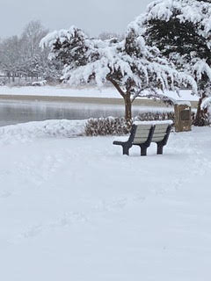

The Mattapoisett Land Trust has created a two scavenger hunts for winter exploration. These scavenger hunts will introduce you to some of the many Mattapoisett Land Trust Properties and teach you a few unique things about each site. Hope you enjoy your adventure!
Mattapoisett Land Trust Education is sponsored in part by the Mass Cultural Council.

Scavenger Hunt Directions
Happy exploring!

Locate the property you plan to visit on the Mattapoisett Land Trust website https://mattlandtrust.org/ Family Activities are in the menu on the left side of the page. There’s only one more click to land you at Scavenger Hunts. Scroll through the listed properties for an overview of the property and directions. Each property has a list of items to find – print the list to take with you. When you find an item on the list, check it off. You may document your individual finds with photos. Please take a picture of you and your family somewhere on the property to prove you made it there and you found everything. Following your visit, you can post your favorite pictures on your Instagram account using the hashtag #MLTscavengerhunt and tag @mattapoisettlandtrust as well. Facebook users can post pictures and comments on the https://www.facebook.com/mattlandtrust page. You may also email your photos to MLT mattlandtrust@gmail.com and we will post them for you. Thank you.

